

08

Fall

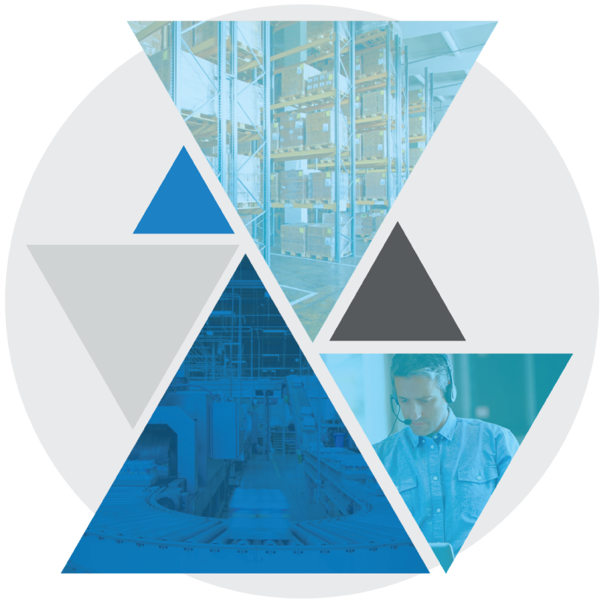

**Test Case: BASE-YRD-8010 API List Transport Equipment**

Table of Contents

API List Transport Equipment 3

Test Case Setup 3

Test Case Cleanup 3

Test Case Prerequisites and Assumptions 4

Test Case Examples 4

Test Case Configurations 4

Test Case Verification Approach 4

Test Case Specification 5

API List Transport Equipment

This document documents the test case instructions for the BASE-YRD-8010 API List Transport Equipment.

**Please note**: The inputs used in these test case specifications (defined in the input CSV files or Datastore) are relative to our testing warehouse environment and are provided as examples. These inputs should be substituted with valid inputs relative to your WMS environment.

Test Case Setup

* Test Case Background function will run the standard set of setup scenarios for the bundle.
* Test Case Dataset
  + The dataset creates an inbound Transport Equipment, as well as a Planned Inbound Order/Shipment.

Test Case Cleanup

* The Test Case After Scenario will run the standard cleanup actions for the bundle.
* Data created during dataset creation and execution is cleaned up

Test Case Prerequisites and Assumptions

* The Test Case executes without interacting with User Interfaces
* The yard location(s) included in the Test Case Input are valid location(s) in the warehouse
* The client_id and wh_id configured in Environment feature match the data in the Test Case Input and will be used for validation, if they do not match, then define client_id and wh_id in local data override
* The Blue Yonder WMS version is >= 2020.1.1

Test Case Examples

This Test Case will be run with the following examples specified in the Test Case Inputs CSV file:

|  |  |  |
| --- | --- | --- |
| Transport Equipment Number | Planned Inbound Order Number | Yard Location |
| BASE-YRD-8010 | BASE-YRD-8010 | RDCK-006 |

Test Case Configurations

The Test Case will be run in the following test configurations:

* Only Single-Warehouse Configuration Tested

Test Case Verification Approach

This test will verify that the Blue Yonder API returns the correct result from the /api/yard/v1beta/transportEquipment endpoint, and that Cycle can parse the response correctly.

Test Case Specification

|  |  |
| --- | --- |
| **Test Case:** BASE-YRD-8010 API List Transport Equipment | **Description:** API List Transport Equipment **Functional Area:** Yard **Test Case Type:** Regression **Dataset:** Datasets/Base/Inbound_Trailer **Test Case Inputs:** Test Case Inputs/BASE-YRD-8010.csv **Test Case Detail Input CSV:** None **Duration:** 0.2 minutes |

|  |  |
| --- | --- |
| **Steps, Actions, and Expected Results** | **Supporting information and/or Affected Data** |
| **Step 1**: Determine which parameters to use for the API request. No parameters are required. Transport Equipment ID, Carrier Code, and Transport Equipment Number are all optional  **Actions**:   * Prepare the API request   **Expected Results**:   * None | No screen data given. Test is not interacting with a user interface |
| **Step 2**: Invoke the API request  **Actions**:   * An HTTP GET request will retrieve JSON data from the Blue Yonder web service * These Postman screenshots are for reference only. The Test Case itself does not interact with any UIs.   **Expected Results**:   * An HTTP response code of “200 OK” indicates that the request was properly authorized and properly formatted. Any other status indicates an error occurred. |  |
| **Step 3**: Parse the API response  **Actions**:   * Validates the JSON response * Verifies that at least one Transport Equipment was returned   **Expected Results**:   * If no Transport Equipment are returned, an error will be thrown. | No screen data given. Test is not interacting with a user interface |

|  |  |
| --- | --- |
| **Final State:** List Transport Equipment is successful | No screen data given. Test is not interacting with a user interface |